A Project Report On

**“Voice Based E-mail System For Blind And Handicapped People”**

Submitted by

Mr. Khizar Bagban

Mr. Aniket Bali

Mr. Akash Shendge

Under the Guidance of

Prof. Savita Adhav

Report towards partial fulfilment for the degree

of Bachelor Engineering (Computer Engineering)

Savitribai Phule University of Pune (Maharashtra)



Department of Computer Engineering

G.H.Raisoni College of Engineering and Management,

Ahmednagar

G.H.Raisoni College of Engineering and Management,

Ahmednagar

**CERTIFICATE**

This is to certify that

Mr. Khizar Bagban Exam No: B150664201

Mr. Aniket Bali Exam No: B150664202

Mr. Akash Shendge Exam No: B150664226

[Computer Engineering]

Has successfully completed synopsis on

**“Voice Based E-mail System For Blind And Handicapped People”**

Towards the partial fulfillment of

Degree in Computer Engineering

Savitribai Phule University of Pune (Maharashtra)

During the year 2020-21

Prof. Savita Adhav Dr.Jayakumar Jayaraman

Project Guide Principle

(HOD Comp. Dept.) G.H.R.C.O.E.M

Internal Examiner External Examiner

**Acknowledgments**

It gives us great pleasure in presenting the preliminary project report on ‘Voice Based Email System For Blind And Handicapped People’. We would like to express our deep-felt gratitude to our Project Guide for giving us an opportunity to work and for her advice, encouragement, and constant support. We wish to thank her for extending us the greatest freedom in deciding the direction and scope of our project. It has been both a privilege and a rewarding experience working with her.

We would also like to thank our colleagues here at Raisoni for all the wonderful times we have had with them. Their valuable comments and suggestions have been vital to the completion of this work. We want to thank the faculty of Raisoni and the staff for providing us the means to complete our degree. And finally, we are grateful to our parents and siblings for their love, understanding, encouragement and support

I would like to take this opportunity to thank my internal guide Prof. Savita Adhav for giving me all the help and guidance I needed. I am really grateful to them for their kind support. Their valuable suggestions were very helpful.

I am also grateful to Prof. Savita Adhav, Head of Computer Engineering Department, G. H. Raisoni Of Engineering for his indispensable support, suggestions.

Student Name1: Khizar Bagban

Student Name2: Aniket Bali

Student Name3: Akash Shendge

(B.E. Computer Engineering.)

**ABSTRACT**

To develop a voice primarily based email system that will facilitate visually impaired individuals to access email in a problem free manner. Together with providing usage of mail services simply and with efficiency, the system also will cut back the psychological feature work that must be unremarkably taken by the visually impaired to recollect and sort characters using the normal Braille keyboards, which are accessible to them. The graphical user interface of this method has been evaluated against the interface of the traditionally accessible mail system. Not only for visually impaired, but also for people who are illiterate might have the benefit of this technique. The foremost crucial facet which will be thought of developing this technique is that the users of this technique does not have any basic information regarding the keyboard shortcuts used or wherever the keys are used for. All functions to be utilized in this technique are supposed to be easy mouse click operations creating the system very user friendly. This application proposes an android application, designed specifically for visually impaired individuals. This application provides a voice primarily based mailing service which provides them to browse and send mail on their own, without any guidance. The users ought to use certain keywords which can perform certain actions for e.g. Read, Send, Compose Mail, Address Book etc. This EMAIL system is utilized by a visually handicapped person to access mails easily and with efficiency. Therefore reliance of visually impaired on others for his or her own activities associated with mail are often reduced.

**Keywords :-** voice mail, Internet ,visually impaired, speech, Speech- Recognition,SpeechtoText,TexttoSpeech,Email,Internet,InteractiveVoiceResp-onse(IVR)

.

**CONTENT**

**1 Synopsis XI**

1.1 Project Title

1.2 Project Option

1.3 Internal Guide

1.4 Sponsorship and External Guide

1.5 Technical Keywords (As per ACM Keywords)

1.6 Problem Statement

1.7 Abstract

1.8 Project Objectives and Goals

1.9 Relevant mathematics associated with the Project

1.10 Names of Conferences / Journals where papers can be published

1.11 Review of Conference/Journal Papers supporting Project idea

1.12 Plan of Project Execution

**2 Technical Keywords**

2.1 Area of Project

2.2 Technical Keywords

**3 Introduction**

3.1 Project Idea

3.2 Motivation of the Project

3.3 Literature Survey

**4 Problem Definition and scope XVIII**

4.1 Problem Statements

4.1.1 Goals and objectives

4.1.2 Statement of scope

4.2 Software context

4.3 Major Constraints

4.4 Methodologies of Problem solving and efficiency issues

4.5 Outcome

4.6 Applications

4.7 Hardware Resources Required

4.8 Software Resources Required

**5 Project Plan**

5.1 Project Estimates

5.1.1 Reconciled Estimates

5.1.2 Project Resources

5.2 Risk Management w.r.t. NP Hard analysis

5.2.1 Risk Identification

5.2.2 Risk Analysis

5.2.3 Overview of Risk Mitigation, Monitoring, Management

5.3 Project Schedule

5.3.1 Project task set

5.3.2 Task network

5.3.3 Timeline Chart

5.4 Team Organization

5.4.1 Team structure

5.4.2 Management reporting and communication

**6 Software requirement specification (SRS is to be prepared using relevant mathematics derived and software engg. Indicators in Annex A and B)**

6.1 Introduction

6.1.1 Purpose and Scope of Document

6.1.2 Overview of responsibilities of Developer

6.2 Usage Scenario

6.2.1 User profiles

6.2.2 Use-cases

6.2.3 Use Case View

6.3 Data Model and Description

6.3.1 Data Description

6.3.2 Data objects and Relationships

6.4 Functional Model and Description

6.4.1 Data Flow Diagram

6.4.2 Description of functions

6.4.3 Non Functional Requirements

6.4.4 Functional Requirements

6.4.5 State diagram

**7 Detailed Design Document using Appendix A and B**

7.1 Introduction

7.2 Architectural Design

7.3 Data design (using Appendices A and B)

7.3.1 Internal software data structure of architecture

7.3.2 Global data structure

7.3.3 Temporary data structure

7.3.4 Database description

7.4 Methodology/Algorithms

7.4 Flow Charts

7.4.1 Login page

7.4.2 Instruction page

7.4.3 Option page

7.4.4 Compose page

7.4.5 Send page

7.4.6 Trash box page

7.5 Component Design

7.5.1 Class Diagram

8 Results

**9 Summary**

**10 conclusion**

**Annexure A Project Planner**

**Annexure B Reviewers Comments of Paper Submitted**

**Annexure C Plagiarism Report**

**Annexure D Information of Project Group Members**

**List of Figures :-**

|  |  |  |
| --- | --- | --- |
| **Figure Number** | **Figure Name** | **Page Number** |
| 5.2 | NP-hard and NP-complete | 15 |
| 6.2 | Use Case Diagram | 25 |
| 6.4.1 | DFD Level – 0 | 27 |
| 6.4.1 | DFD Level – 1 | 28 |
| 6.4.2 | Activity Diagram | 29 |
| 6.4.5 | State Transition Diagram | 31 |
| 4.5.4 | System Architecture 1 | 33 |
| 4.5.4 | System Architecture 1.2 | 33 |
| 7.4.1 | Flow Charts | 37 |
| 7.5.1 | Class Diagram | 45 |
| 8 | Results | 46 |

**Chapter 1**

**1.1 Project Title**

Voice Based E-mail System For Blind People

**1.2 Project Option**

Internal Project

**1.3 Internal Guide**

Prof. Savita Adhav

**1.4 Sponsorship and External Guide**

No Sponsorship

**1.5 Technical Keyword (As per ACM Keyword)**

1. Voice mail
2. Internet
3. Visually impaired
4. Speech
5. Speech_to_text
6. Text_to_speech
7. Mails
8. Interactive Voice Response
9. SMTP protocol
10. IMAP protocol
11. Compose, send, read

**1.6 Problem Statement :-**

**Internet** has made life of people easy by providing access to information, communication with others, expand business.

To communicate over **Internet E-mail** is considered to be most reliable way for sending or receiving some important information. There is a special criterion for humans to access the Internet and the criterion is you must be able to see. But there are some **visually** challenged people or **blind** people who cannot see things and thus cannot get the benefit of technology.

A survey has shown that there are more than 240 million **visually** impaired people around the globe. That is, around 240 million people are unaware of how to use Internet or E-mail. The only way by which a **visually** challenged person can send an **E-mail** is, they have to speak the entire content of the mail to another person( not **visually** challenged ) and then that third person will compose the mail and send on the behalf of the visually challenged person. But this is not a right way to deal with the problem. It is very unlikely that every time a **visually** impaired person can find someone for help

So, for the betterment of society and giving an equal status to such specially abled people we have come up with this project idea

**1.7 Abstract:**

To develop a voice primarily based email system that will facilitate visually impaired individuals to access email in a problem free manner. Together with providing usage of mail services simply and with efficiency, the system also will cut back the psychological feature work that must be unremarkably taken by the visually impaired to recollect and sort characters using the normal Braille keyboards, which are accessible to them. The graphical user interface of this method has been evaluated against the interface of the traditionally accessible mail system. Not only for visually impaired, but also for people who are illiterate might have the benefit of this technique. The foremost crucial facet which will be thought of developing this technique is that the users of this technique does not have any basic information regarding the keyboard shortcuts used or wherever the keys are used for. All functions to be utilized in this technique are supposed to be easy mouse click operations creating the system very user friendly. This application proposes an Web Application, designed specifically for visually impaired individuals. This application provides a voice primarily based mailing service which provides them to browse and send mail on their own, without any guidance. The users ought to use certain keywords which can perform certain actions for e.g. Read, Send, Compose Mail,Logout etc. This EMAIL system is utilized by a visually handicapped person to access mails easily and with efficiency. Therefore reliance of visually impaired on others for his or her own activities associated with mail are often reduced.

**1.8 Project Objectives & goals:**

This project proposes a python based web application, designed specifically for visually impaired people or handicapped people. This application provide a voice based mailing service where they could read and send mail on their own, without any guidance through their g-mail accounts. Here, the users have to use certain keywords which will perform certain actions for e.g. Read, Send, Compose Mail etc.

Our Aplication system can be used by a blind person to access mails easily and adeptly. Hence dependence of visually challenged on other individual for their activities associated to mail can be condensed. The application will be a python-based application for visually challenged persons using IVR- Interactive voice response, thus sanctioning everyone to control their mail accounts using their voice only and to be able to read, send, and perform all the other useful tasks. The system will ask the user with voice commands to perform certain action and the user will respond to it. The main advantage of this system is that use of keyboard is completely eliminated , the user will have to respond through voice only.

**1.9 Relevant Mathematics Associated with the project :**

**System Description:-**

* Input : speech command like username and password ,start, logout, yes or no
* Output: compose email, send email ,delete email etc.
* Functions : Composing , forwarding, deleting ,sending
* Mathematical formulation if possible
* Success Condition : Our model gives 85% in speech recognition and 98% in its operation like sending mails
* Failure Conditions: speech recognition in crowd

**1.10 Names of Conferences /Journals where papers can be published :-**

* + - IRAJ-International Conference on Computer science and Mechanical Engineering (ICCSME), Goa and November 2016
    - Science plus-International conference on recent Innovations in Com- puter Science and Information Technology (ICRICSIT-2016), Mumbai and November 2016
    - The IRES - 132nd International Conferences on Innovative Engineering Technologies (ICECCT), Pune and January 2017
    - IEEE/ACM Conference/Journal 1/Journal 2
    - Conferences/workshops in IITs XIII
    - Central Universities or SPPU Conferences

**1.11 Review of Conference/Journal Papers supporting Project idea :-**

In paper [1], have proposed an email system which can be accessed easily by blind people. The use of speech to Text convertor, Text to speech convertor and Viterbi Algorithm are taken into consideration.. The algorithmic rule works with the technique that the system detects the foremost acceptable word once the user spells it so matches the word that's guessed with the particular word that's pronounced. The user needs to register to the website when they visit the site for the first time.

This system reduces some drawbacks of the existing system

In paper [2] “Voice Based System in Mobile Devices for Blind People”. In International Journal of Emerging Technology and Advanced Engineering (IJETAE), 2014

This paper deals with “Voice Based System in Mobile Devices for Blind People”. Voice mail architecture helps blind people to access e-mail and other multimedia functions of operating system (songs, text). Also in mobile application SMS can be read by system itself.

In paper [3] “Voice Based Search Engine and Web page Reader”. In International Journal of Computational Engineering Research (IJCER)

This paper aims to develop a search engine which supports Man-Machine interaction purely in the form of voice. A novel Voice based Search Engine and Web-page Reader which allows the users to command and control the web browser through their voice is introduced. The existing Search Engines get request from the user in the form of text and respond by retrieving the relevant documents from the server and displays in the form of text to user

In paper [4] proposes a system for visually impaired and illiterate people for improving their interaction with the email system. This system eliminates use of IVR Technology that used Screen Readers and Braille Keyboard. There, have used Speech to text and Text to speech conversion.

**1.12 Plan of Project Execution**

Using planner or a like project management tool

* Functionality testing:

testing if the end product is fully functional with all its functionality intact.

* Usability testing:

testing if the application works fine with all its upload links and Command working.

* Interface testing:

testing if the interface is use friendly or not.

* Input :

Various commands like yes ,no ,compose or content of mail .

* Output:

Mail send successfully ,Reading specific mail ,Deleting mail

,Forwarding mail or Mail not send

**Chapter 2**

**Technical Keywords :**

**2.1 Area of Project**

Networking

**2.2 Technical Keywords**

1. Voice mail
2. Internet
3. Visually impaired
4. Speech
5. Speech_to_text
6. Text_to_speech
7. Mails
8. Interactive Voice Response
9. Smtp protocol
10. Imap protocol
11. Compose,send,read

**Chapter 3**

**INTRODUCTION**

**3.1 Project Idea**

1. Access email content using speech
2. Read email content like body of mail using Interactive Voice Response(IVR)
3. Compose an email using just voice without using keyboard
4. Economically maintained our mail data without seeing the screen
5. User can handle their email account without seeing the computer screen using IVR

**3.2 Motivation of the Project**

Voice based Voice mail system architecture that can be used by a Blind person to access Voice mails easily and efficiently. The contribution made by this research has enabled the Blind people to send and receive voice based voice mail messages in their native language with the help of a computer or a mobile device

**3.3 Literature Survey**

In paper [1], have projected associate email system that will be accessed simply by blind folks. The use of speech to Text device, Text to speech device and Viterbi algorithmic rule square measure taken into thought.. The algorithm works with the technique that the system detects the foremost acceptable word once the user spells it therefore matches the word that is guessed with the explicit word that is pronounced. The user desires to register to the web site after they visit the location for the primary time. This system reduces some drawbacks of the present system

In paper [2] “Voice based mostly System in Mobile Devices for Blind People”. In International Journal of rising Technology and Advanced Engineering (IJETAE), 2014 This paper deals with “Voice based mostly System in Mobile Devices for Blind People”. Voice mail design helps blind person to access e-mail and alternative multimedia system functions of software package (songs, text). additionally in mobile application SMS will be browse by system itself.

In paper [3] “Voice based mostly program and web content Reader”. In International Journal of procedure Engineering analysis (IJCER) This paper aims to develop a pursuit engine that supports Man-Machine interaction strictly within the style of voice. a unique Voice based mostly program and Web-page Reader that permits the users to command and management the net browser through their voice is introduced. the present Search Engines get request from the user within the style of text and respond by retrieving the relevant documents from the server and displays within the style of text to user

In paper [4] proposes a system for visually impaired and illiterate person for rising their interaction with the email system. this method eliminates use of IVR Technology that used Screen Readers and Braille Keyboard. There, have used Speech_to_text and Text_to_ speech conversion. additionally for alternative operations voice commands. For registration, used email id and word. For the practicality, use a feature of PHP that's PHP mailer. it's a library which might be wont to send email..

**Chapter 4**

**Problem Definition and scope**

**4.1 Problem Statement :-**

**Internet** has made life of people easy by providing access to information, communication with others, expand business.

To communicate over **Internet E-mail** is considered to be most reliable way for sending or receiving some important information. There is a special criterion for humans to access the Internet and the criterion is you must be able to see. But there are some **visually** challenged people or **blind** people who cannot see things and thus cannot get the benefit of technology.

A survey has shown that there are more than 240 million **visually** impaired people around the globe. That is, around 240 million people are unaware of how to use Internet or E-mail. The only way by which a **visually** challenged person can send an **E-mail** is, they have to speak the entire content of the mail to another person( not **visually** challenged ) and then that third person will compose the mail and send on the behalf of the visually challenged person. But this is not a right way to deal with the problem. It is very unlikely that every time a **visually** impaired person can find someone for help

So, for the betterment of society and giving an equal status to such specially abled people we have come up with this project idea.

**4.1.1 Goals and objectives**

Goals and Objetives:

This project proposes a python based web application, designed specifically for visually impaired people or handicapped people. This application provide a voice based mailing service where they could read and send mail on their own, without any guidance through their g-mail accounts. Here, the users have to use certain keywords which will perform certain actions for e.g. Read, Send.

Our Aplication system can be used by a blind person to access mails easily and adeptly. Hence dependence of visually challenged on other individual for their activities associated to mail can be condensed. The application will be a

python-based application for visually challenged persons using IVR- Interactive voice response, thus sanctioning everyone to control their mail accounts using their voice only and to be able to read, send, and perform all the other useful tasks. The system will ask the user with voice commands to perform certain action and the user will respond to it. The main advantage of this system is that use of keyboard is completely eliminated , the user will have to respond through voice only

**Objectives:**

* + - Flexible
    - Easy to use
    - Make blind people independent
    - Keyboard avoided

**4.1.3 Statement of scope**

* We are going to make a fully functioning web application that can be used by blind people to maintained their email without using keyboard
* Our client may be blind or handicapped ,so according we are going to create GUI interface that can be user friendly
* Through our web app user can able to compose email without seeing the keyboard or computer screen

**4.2 Software Context :-**

In Our Voice Based Email System project, we have used Django python which is frame work of python used for backend Django is a high-level Python web framework that **enables rapid development of secure and maintainable websites**. Django takes care of much of the hassle of web development, so you can focus on writing your app without needing to reinvent the wheel

**4.3 Major Constraints**

* + - The single problem can be solved be different solution. this considers the performance parameter for each approach .
    - If **User** credentials is gone in the wrong hands like hackers, terrorist, criminals then this can be very much dangerous for client.

**4.4 Methodologies of Problem solving and efficiency issue**

* Voice Recognition
* Text to speech conversion
* Speech to text conversion
* Used smtp protocol to send emails
* Used imap protocol to retrieve emails from server

**4.5 Outcome**

With the help of our voice based email system the visually impaired people or handicapped person can communicate though emails. This is achieved by developing an web application that the visually impaired can use without any assistance.

**4.6 Application**

* This project is proposed for the betterment of society
* This project aims to help the visually impaired people to be a part of growing digital India by using internet and also aims to make life of such people quite easy.
* Also, the success of this project will also encourage developers to build something more useful for visually impaired or illiterate people, who also deserves an equal standard in society.

**4.7 Hardware Resources Requirement**

|  |  |  |  |
| --- | --- | --- | --- |
| Sr No | Parameter | Minimum Requirement | Justification |
| 1 | CPU Speed | 2 GHZ | Remark Required |
| 2 | RAM | 2 GHZ | Remark Required |
| 3 | Hard-disk | 2 GHZ | Remark Required |

**4.8 Software Resources Required**

Platform:

* Operating System : Windows 7/8/10
* Programming language : Python
* IDE : PyCharm Netbeans
* Web Browser
* Front-End : HTML, CSS, Javascript
* Back-End: Django, Ajax

**Chapter 5**

**Project Plan**

**5.1 Project Estimation**

Here the prediction is made about the size of total project. Effective software project estimation is one of the most challenging and important activity in software development once you have on estimate size of your product you can desire the effort estimate.

**5.1.1 Reconciled Estimates**

**Cost Estimate**

The cost of estimation involves people working on project ,time required

To develop the project, and line of code

* Cost of server : 10,000 for yr
* Development cost : 35,000(approximate)
* Total cost : 45,000(approximately)

**Time Estimates**

Because we are using waterfall model the time expected is around

6 months

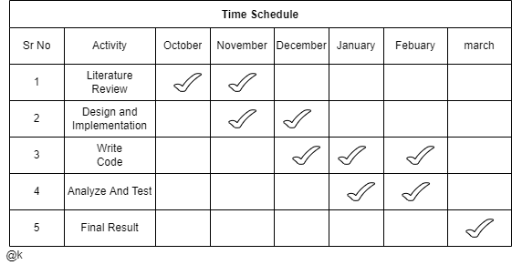

**Development time for Project**

Requirements analysis require 2.3 months

Implementation and testing requires 4 months.

Total Duration for completion of project D= 6.3 months.

**Number of Persons**

Total Three persons are required to complete the project successfully within given time span.

**5.1.2 Project Resources**

**Hardware Resources Required Software Resources Required**

**5.1:** Hardware Requirement

|  |  |  |
| --- | --- | --- |
| Sr. No. | Parameter | Minimum Requirement |
| 1 | Processor | Pentium IV/Intel i3 core later |
| 2 | Speed | 1.1GHZ |
| 3 | Ram | 512MB |
| 4 | Hard Disk | 20GB |
| 5 | Mirophone | 80 Hz to 15 kHz |
| 6 | Mouse | Two or Three Button |
| 7 | Monitor | LED Monitor |

**5.2 Risk Management w.r.t. NP Hard analysis**

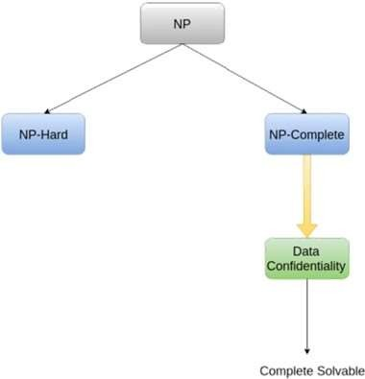

**Figure 5.1:** NP-hard and NP-complete

Risk management involves Risk Identification, Risk Analysis and Risk Prioritization. Risk Projection consists of Risk Management Planning, Risk Resolution and Risk Monitoring. Risk management followed by coordinated and economical application of resources to minimize, monitor and control probability and/or impact of unfortunate events or to maximize the realization of opportunities. This problem is NP-Hard and we can make it NP-Compete by using this system.

**5.2.1 Risk Identification**

For risks identification, review of scope document, requirements specifications and schedule is done. Answers to questionnaire revealed some risks. Each risk is categorized as per the categories mentioned in. Please refer table 2.1 for all the risks. You can refer following risk identification questionnaire.

1 Have top software and customer managers formally committed to support the project?

2 Are end-users enthusiastically committed to the project and the system/product to be built?

3 Are requirements fully understood by the software engineering team and its customers?

4 Have customers been involved fully in the definition of requirements?

5 Do end-users have realistic expectations?

6 Does the software engineering team have the right mix of skills?

7 Are project requirements stable?

8 Is the number of people on the project team adequate to do the job?

9 Do all customer/user constituencies agree on the importance of the project and on the requirements for the system/product to be built?

* **Product Size Risk**

R1 = Risk associated with the overall size of the software to be built or modified.

R2 = Project may not complete on time.

R3 = Product size may increase due to inefficient implementation of system.

* **Business Impact Rule**

R4 = Risk associated with constraints imposed by management or the marketplace.

R5 = Product loses its market value.

R6 = Delay in project delivery (violation of time constraints) can hamper the customer economically.

* **Process Risk**

R7 = Risk associated with the degree to which the software process has been defined and is followed by the development organization.

R8 = Software process model is not followed up to the define degree.

R9 = Selection of software process model.

* **Technical Risk**

R10 = Risk associated with the complexity of the system to be built and the newness of the technology that is packaged by the system.

R11 = System is not scalable.

R12 = System may fail to provide desired efficiency to customer .

* **Development Environment Risk**

R13 = Risk associated with the availability and quality of the tools to be used to build the product.

R14 = Lack of training on development tools and inexperience.

R15 = It is difficult to alter the system as per customer’s requirements in later stage.

* **Staff Size And Experience Risk**

R16 = Risk associated with the overall technical and project experience of the software engineers who will do the work.

R17 = Less technical and project experience of the software engineers who are working on project.

**5.2.2 Risk Analysis :-**

The risks for the Project can be analyzed within the constraints of time and quality Table

**Table 5.2:** Risk Analysis 1

|  |  |  |  |  |  |
| --- | --- | --- | --- | --- | --- |
| ID | Risk  Description | Probability | Schedule | Quality | Overall |
| 1 | Will the system  process 100-150 system | Low | Low | High | High |
| 2 | Will the system able to handle multiple users at a time | Low | Low | High | High |
| 3 | Will the system handle  multiple error? | Low | Low | High | High |
| 4 | Will system degrade the performance of other subsystem | Low | Low | High | High |

**Table 5.3:** Risk Analysis 2

|  |  |  |
| --- | --- | --- |
| Probability | Value | Critical |
| High | Probability of occurrence is | ¿75 |
| Medium | Probability of occurrence is | 26 -75 |
| Low | Probability of occurrence is | ¡25 |

**Table 5.4:** Risk Analysis 3

|  |  |  |
| --- | --- | --- |
| Impact | Value | Description |
| Very high | *>*10 | Schedule  impact or unacceptable Quality |
| High | 5-10 | Schedule  impact or some parts of the project have low quality |
| Medium  Medium | *<*5 | Schedule  impact or barely noticeable degradation  in quality ow impact on schedule or quality can be incorporated |

**5.2.3 Overview of Risk Mitigation ,Monitoring ,Management :-**

Following are the details for each risk.

|  |  |
| --- | --- |
| Risk ID | 1 |
| Risk Description | Description 1 |
| Category | Development Environment |
| Source | Software requirement specification document |
| Probability | Low |
| Impact | High |
| Response | Mitigate |
| Risk Status | Occurred |

|  |  |
| --- | --- |
| Risk ID | 2 |
| Risk Description | Description 2 |
| Category | Requirement |
| Source | Software requirement specification document review |
| Probability | Low |
| Impact | High |
| Response | Mitigate |
| Strategy | Better testing will resolve this issue |
| Risk Status | Identified |

**Feasibility**

The feasibility of the project is analysed in this phase and business proposal is put forth with a very general plan for the project and some cost estimates. During system analysis the feasibility study of the proposed system is to be carried out. This is to ensure that the proposed system is not a burden to the company. For feasibility analysis, some understanding of the major requirements for the system is essential. Dimensions of Software Feasibility are as follows:

• Technology:

Is project technically feasible?

Is it within state of art?

Can defect be reduce to a level matching application’s need?

• Finance:

Is it financially feasible?

Can development be completed at a cost the software organization and its client or market can afford?

• Time:

Will project’s time to market beat competition?

• Resources:

Does the organization have resources needed to success?

Two key considerations involved in the feasibility analysis are:

1. Technical Feasibility.

2. Cost Feasibility.

**Technical Feasibility**

This study is carried out to check the technical feasibility, that is, the technical requirements of the system. Any system developed must not have a high demand on the available technical resources. This will lead to high demands on the available technical resources. This will lead to high demands being placed on the client. The developed system must have a modest requirement, as only minimal or null changes are required for implementing this system. Technical feasibility assessment can be done through following ways:

1)NP- Complete. 2) NP-Hard. 3)Satisfiability.

**Cost Feasibility**

This study is carried out to check the economic impact that the system will have on the organization. The amount of fund that the company can pour into the research and development of the system is limited. The expenditures must be justified. Thus the developed system as well within the budget and this was achieved because most of the technologies used are freely available. Only the customized products had to be purchased.

**5.3 Project Schedule**

# 5.3.1 Project task set

Major Tasks in the Project stages are:

• Task 1: Requirement Analysis (Base Paper Explanation).   
 • Task 2: Project Specification (Paper Work).

• Task 3: Technology Study and Design.

• Task 4: Coding and Implementation (Module Development).

• Task 4: Testing.

**5.3.2 Task network**

Project tasks and their dependencies are noted in this diagrammatic form.

* Task network ( activity network ) is a graphic representation of the task flow for a project. o The task network depicts major software engineering tasks. o Planner must determine intertask dependencies to ensure continuous progress toward completion.

# 5.3.3 Timeline Chart



A project timeline chart is presented. This may include a time line for the entire project.

**5.4 Team Organization :-**

The manner in which staff is organized and the mechanism for reporting are noted

**5.4.1 Team structure**

* + - Khizar : Implementation and Testing, Requirment Analysis
    - Aniket : Desgining and Modeling,
    - Akash : Documentation ,Testing

**5.4.2 Management reporting and communication**

Mechanisms for progress reporting and inter/intra team communication are

Identified as per assessment sheet and lab time table

**Chapter 6**

**Software requirement specification**

**6.1 Introduction**

**6.1.1 Purpose and Scope of Document**

An SRS minimizes the time and effort required by developers achieve desired goals and also minimizes the development cost. A good SRS defines how an application will interact with system hardware, other programs and human users in a wide variety of real-world situations. Parameters such as operating speed, response time, availability, portability, maintainability, footprint, security and speed of recovery from adverse events are evaluated.

**6.1.2 Overview of responsibilities of Developer**

• Requirement Gathering and Analysis

• Planning of project as per Requirement

• Designing of Project and Problem Definition

• Database Designing

• Analysis and Research

Establish progress and lead project success at all stages in various forms for sales and marketing to continue growth. Identify and implement necessary development and tasks to meet company goals and commitments learning company business model. Supply design and development projects on time and within budget. Develop programs to process sales and marketing data weekly and monthly. Convey project objectives, risks and success criteria to Company Leadership team. Perform business analysis and write specifi- cations related to developed software. Develop software programs and ap- plications passing through all stages. Analyse and resolve software errors accurately on time and provide required status reports. Design and develop new software programs and applications assisting developers, analysts and designers. Help in preparation and documentation of program requirements and specifications. Suggest, plan and implement software improvements and upgrades. Write, translate and code software programs and applications specifications. Assist in development and maintenance of user manuals and guidelines. Install software products for end users as needed. Resolve problems with software products or company software systems work-ing with network administrators, systems analysts and software engineers. Guide junior software programmers and research assistants.

**6.2 Usage Scenario**

This section provides various usage scenarios for the system to be

developed.

**6.2.1 User profiles**

This system has 2 actors that the user-1,user-2

**6.2.2 Use-cases**

Use cases are meant for specification of the interaction between the system and end user of the system

**6.2.3 Use Case Diagram :-**

A use case diagram at its simplest is a representation of a user’s interaction with the system that shows the relationship between the user and the different use cases in which the user involved

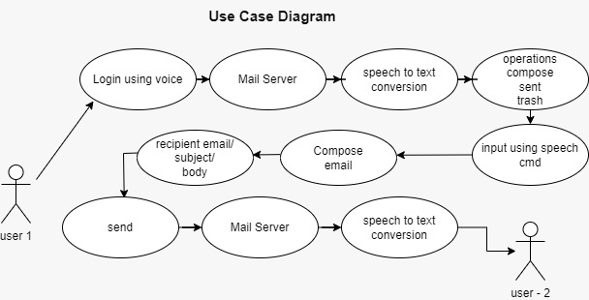

Figure 6.1:Use case diagram

In the above use case diagram 1 user ,compose and send email to the user 2

without using keyboard

**6.3 Data Model and Description**

**6.3.1 Data Description**

Data objects that will be managed/manipulated by the software are described in this section. The database entities or files or data structures required to be described. For data objects details can be given as below

**6.3.2 Data objects and Relationships**

Data objects and their major attributes and relationships among data objects are described using an Diagrams.

**6.4 Functional Model and Description**

A description of each major software function, along with data flow (structured analysis) or class hierarchy (Analysis Class diagram with class description for object oriented system) is presented.

**6.4.1 Data Flow Diagram**

DFD allows the software development team to depict flow of data from one process to another. In addition, the DFD accomplishes the following objectives:

It represents system data in a hierarchical manner and with required levels of detail.

It depicts processes according to defined user requirements and software scope.

A DFD depicts the flow of data within a system and considers a system as a transformation function that transforms the given inputs into desired outputs. When there is complexity in a system, data needs to be transformed using various steps to produce an output. These steps are required to refine the information. The objective of DFD is to provide an overview of transformations that occur in the input data within the system in order to produce an output. The DFD consists of four basic notations (symbols),

which help to depict notations in a system.

There are various levels of DFD, which provides details about the input, processes and output of the system. Note that the level of detail of processes increases with increase in levels. However, these levels do not describe the system’s internal structure or behavior. These levels are listed below:

Level 0 DFD: this shows an overall view of the system.

Level 1 DFD: this elaborates the level 0 DFD and splits the process into detailed form.

**Data Flow Diagram : Level – 0 :-**

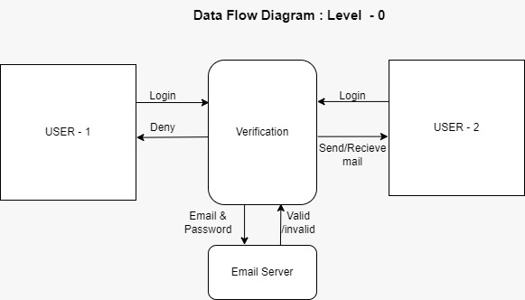

**Data Flow Diagram : Level – 1 :-**

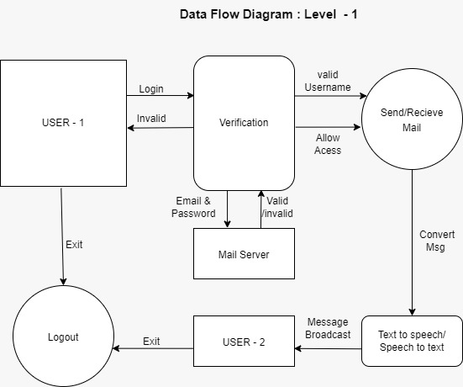

**6.4.2 Description of functions**

A description of each software function is presented. A processing narrative for function n is presented.(Steps)/ Activity Diagrams.

**Activity Diagram:**

This is the Login Activity Diagram of voice based email System, which shows the flow of Login Activity, where blind people will be able to login using their username and password. After login user can manage all the operations like send mail, compose mail, delete mail, forword mail, receive mail. All the pages such as voice based management system are secure and only that blind people can access these page after login. The diagram below hips demonstrate how the login page works of voice based management system.

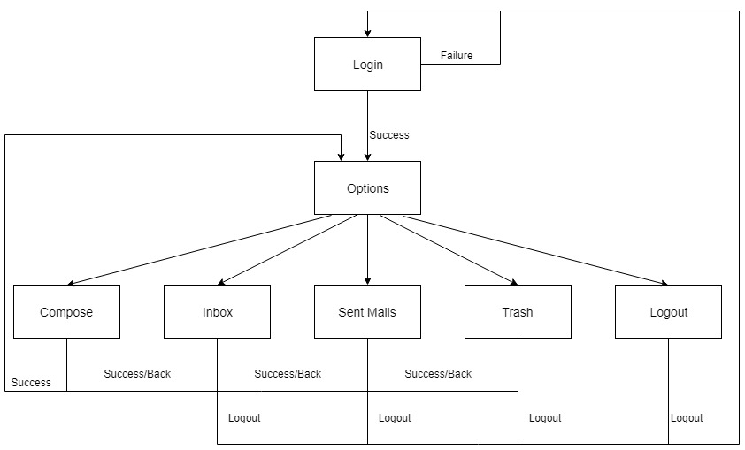

**6.4.4 Non Functional Requirements:**

– Interface Requirements

– Performance Requirements

– Software quality attributes such as availability [ related to Reliability], modifiability [includes portability, reusability, scalability] , performance, security, testability and usability[includes self adaptability and user adaptability]

### Performance Requirements

**Performance Requirement 1**

Error message is speak by the machine using IVR to the user.

**Performance Requirement** 2

If there is no input then, Error message is speak by the machine using IVR to the user.

### Security Requirements

Refers to the technical innovations and procedures applied to the hardware and operation systems to protect against deliberate or accidental damage from a defined threat

* Secure access of confidential data (user’s details). SSL can be

used.

* 24 X 7 availability.
* Better component design to get better performance at peak time.
* Flexible service based architecture will be highly desirable for

future extension

### Software Quality Attributes

Software testing is a critical element of software quality assurance and represents the ultimate review of specification, design and coding. In fact, testing is the one step in the software engineering process that could be viewed as destructive rather than constructive. A strategy for software testing integrates software test case design methods into a well- planned series of steps that result in the successful construction of software. Testing is the set of activities that can be planned in advance and conducted systematically. The underlying motivation of program testing is to affirm software quality with methods that can economically and effectively apply to both strategic to both large and small-scale systems.

**6.4.5 State Diagram:**

A state diagram is a type of diagram used in computer science and related fields to describe the behavior of systems. State diagrams require that the system described is composed of a finite number of states; sometimes, this is indeed the case, while at other times this is a reasonable abstraction

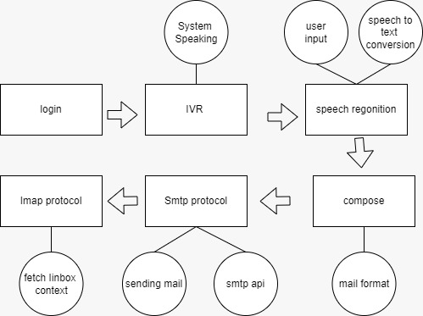

Figure :- State Transition Diagram

**Design Constraints**

Our target to develop a web application for blind or handicapped people which help them to manage their Email account easily with only voice, we are using html, CSS, Javascript for better GUI and Django and ajax for efficiently handly all backend code .Here user give input through voice ,our system interact with user and accordingly operation are perform

**Software Interface Description**

The software interface we have used html ,CSS ,javascript for better GUI

That is userfriendly for handicapped people

**Chapter 7**

**Detailed Design Document using Appendix A and B**

**7.1 Introduction**

So, for the better-ment of society and giving an equal status to such specially abled people we have come up with this project idea which provides the user with ability to send mails using voice commands without the need of keyboard or any other visual things by only using speech and mouse click.

**7.2 Architectural Design**

A description of the program architecture is presented. Subsystem design or Block diagram, Package Diagram, Deployment diagram with description is to be presented.

**System Architecture 1:**

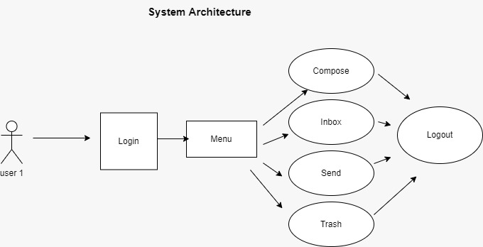

**System Architecture 1.2 :**

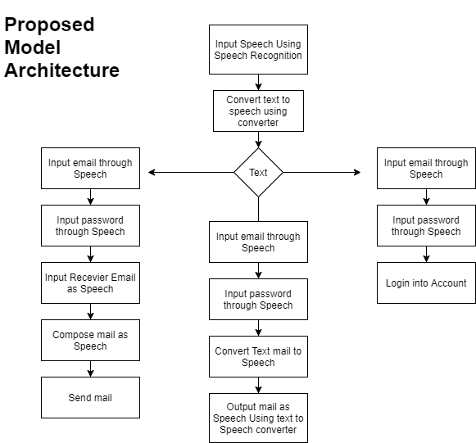

**7.3 Data design (using Appendices A and B)**

A description of all data structures including internal, global, and temporary data structures, database design (tables), file formats.

**7.3.1 Internal software data Structure of Architecture :-**

Data structure that are passed among components the software are

Described

**7.3.2 Global data Structure :-**

Data structure that are available to major portions of the architecture

are described

**7.3.3 Temporary data Structure :-**

Temporary data structure created are described

**7.4 Methodology /Algorithms**

**Algorithm**

1. Input credentials using voice
2. voice get converted to text
3. Give request to server and get access to account
4. Now give options like compose, inbox, send, trashbox , logout
5. If user choose compose

* Enter recipient address
* Enter subject
* Enter body of mail

1. If user choose inbox

* Read unread mail
* Search specific mail
* Back

1. Similary other operations can be perform
2. Repeat step 4 till user doesn’t get input as logout
3. Logout
4. Redirect to start page

**Pseudo codes**

**Text to speech conversion Pseudo code**

# Import the required module for text

# to speech conversion

from gtts import gTTS

# This module is imported so that we can

# play the converted audio

import os

# The text that you want to convert to audio

mytext = 'Welcome to khizar!'

# Language in which you want to convert

language = 'en'

# Passing the text and language to the engine,

# here we have marked slow=False. Which tells

# the module that the converted audio should

# have a high speed

myobj = gTTS(text=mytext, lang=language, slow=False)

# Saving the converted audio in a mp3 file named

# welcome

myobj.save("welcome.mp3")

# Playing the converted file

os.system("mpg321 welcome.mp3")

O/P : The output of the above program should be a

voice saying, 'Welcome to Khizar bagban!

'

**Speech to text conversion Pseudo code**

*#import library*

import speech_recognition as sr

*# Initialize recognizer class (for recognizing the speech)*

r = sr.Recognizer()

*# Reading Audio file as source*

*# listening the audio file and store in audio_text variable*

with sr.AudioFile('I-dont-know.wav') as source:

audio_text = r.listen(source)

try:

*# using google speech recognition*

text = r.recognize_google(audio_text)

print('Converting audio transcripts into text ...')

print(text)

except:

print('Sorry.. run again...')

O/P : hello this test msg khizar

**# Pseudo code to send mail using smtp protocol**

import smtplib, ssl

port = 587 # For starttls

smtp_server = "smtp.gmail.com"

sender_email = "my@gmail.com"

receiver_email = "your@gmail.com"

password = input("Type your password and press enter:")

message = """\

Subject: Hi there

This message is sent from Python."""

context = ssl.create_default_context()

with smtplib.SMTP(smtp_server, port) as server:

server.ehlo() # Can be omitted

server.starttls(context=context)

server.ehlo() # Can be omitted

server.login(sender_email, password)

server.sendmail(sender_email, receiver_email, message)

**7.4.1 Flow-Charts**:

1.Login Page

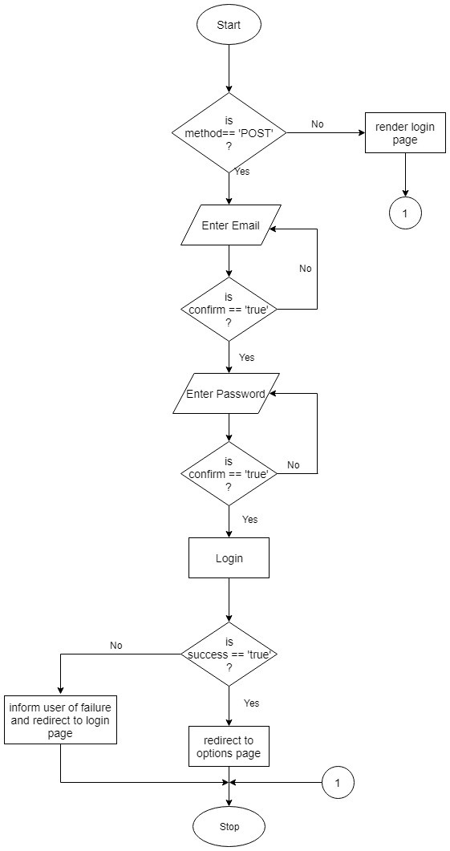

2.Options:

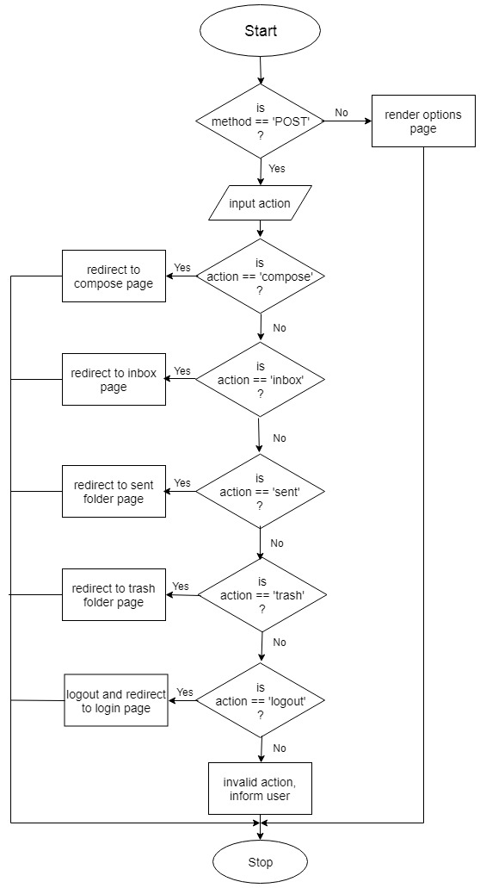

3.Compose:

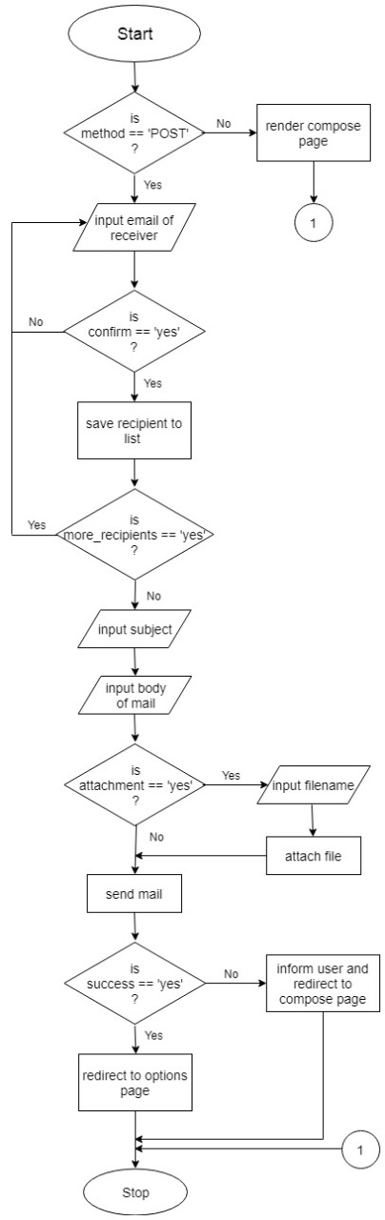

4.Inbox:

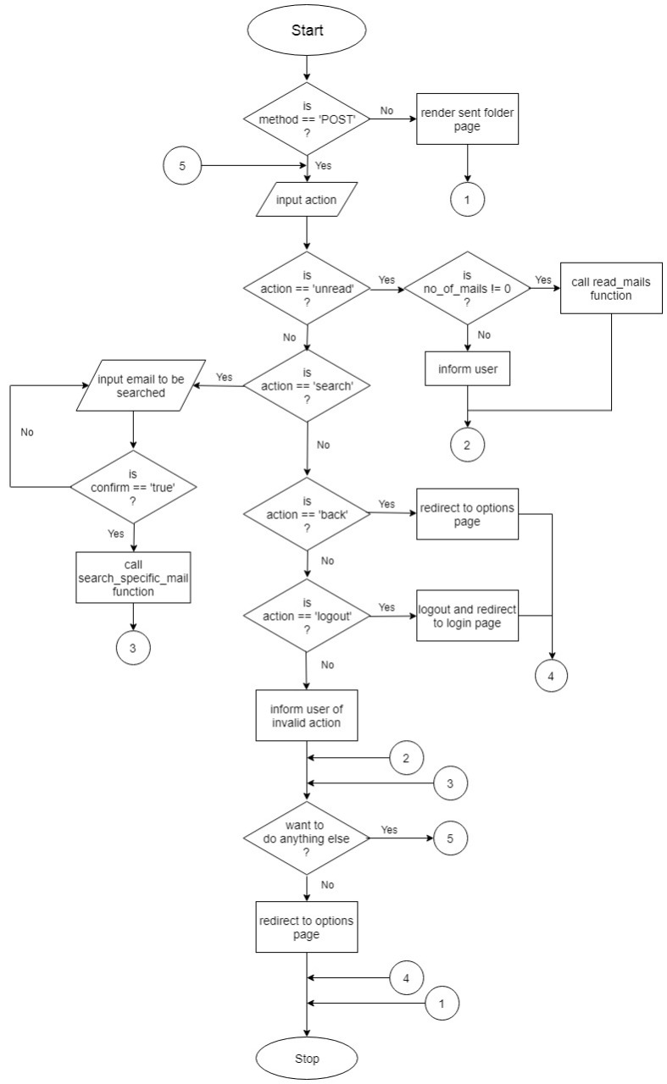

5.Send:

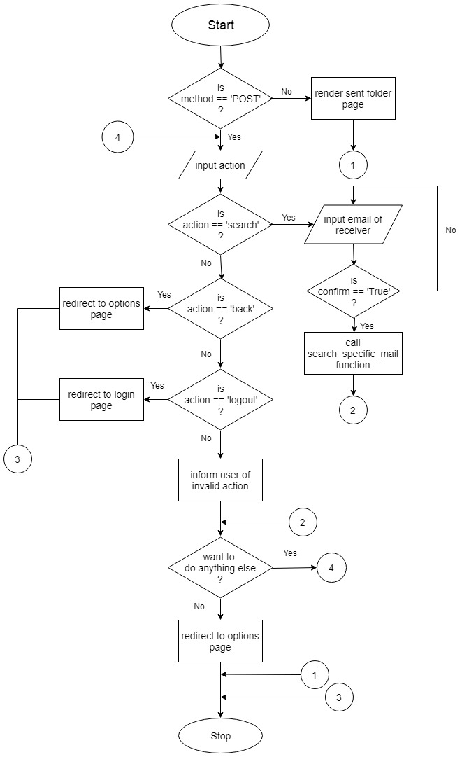

6.Trash Box:

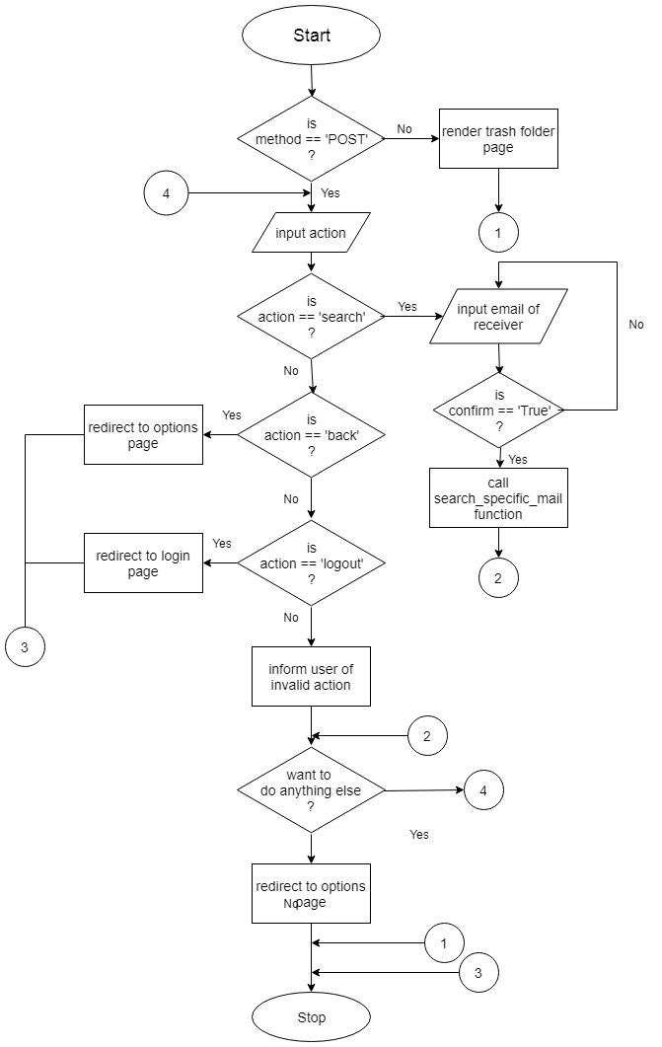

**7.5 Component Design**

**A. Phase-1:**

The tasks that can be performed using the program developed will be prompted using the voice prompt. In background python module pyttsx3 is used for text to speech conversion.

User will be asked to provide input for the following tasks written below.

The input is expected in the form of speech by the user which will be converted to text by the Google speech application interface in python and accordingly tasks will be performed.

• Login to their Gmail account.

• Send e-mail through Gmail.

• Read e-mail through Gmail.

**B. Phase-2:**

In phase-2 of our program the user will give speech input to the system. This speech input will be handled by speech_recognition module.It is a python library which is used to handle the voice requests and it converts speech into text. Now after receiving input from the user speech to text converter will save the response in respective variables used in the script and based on their value it will further enter into respective modules.

**C. Phase-3:**

In this phase our program will handle the requests by the user. Based on the speech input given by the user it will launch the modules.

• Login to G-mail account:- This module will handle the request by user to login in their g-mail account.This module will make the connection with the user’s gmail account based on the credentials provided through voice input. This module’s script designed as such it will prompt user to enter their gmail username and password and then it will use selenium web-driver to automate the task for the user and as a result connection will be made.

• Send E-mail through G-mail:- This module will handle the request by user to send email through their g-mail account. The python script for this module will prompt the user to enter their credentials and then it will make connection with their account. After the connection has been done it will further prompt the user to enter the receiver’s account e- mail id and it will then allow the user to speak their message and it will repeat it for them and by saying ok it will send the mail. SMTP library in python is used for the above task.

• Read E-mail through G-mail:- This module will handle the request by user to read email through their g-mail account. The python script for this module will prompt the user to enter their credentials and then it will make connection with their account. After the connection has been done it will start fetching the unread mails for the user and will speak it for them with the help of pyttsx3 library in python for text to speech conversion.

**7.5.1 Class Diagram :**

Voice based email System Class Diagram describes the structure of a Voice based email System classes, their attributes operations (or methods), and the relationships among objects. The main classes of the Voice based email System are Compose_email, forward_email, delete_email and send_email.

Classes and their attributes of Class Attendance System Class Diagram

* TextToSpeech: txtMessage
* SpeechToText: voiceMessage
* Login: username, password
* Compose: Recipient email, subject, body, compose.
* Inbox: Search, Unread, back
* Send: Search, back, logout
* Trash: Search, back, logout

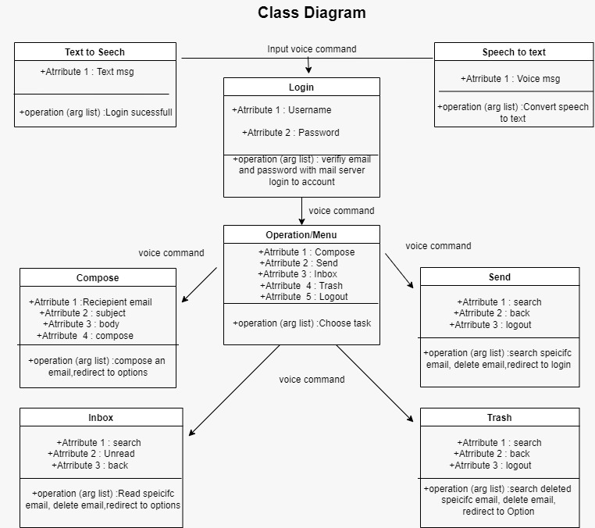

**Advantages :-**

* **The main benefit of this system is that the use of keyboard is completely eliminated.**
* **The user will have to respond through voice**
* This system makes the disabled people feel like a normal user.
* They can hear the recently received mails to the Inbox, as well as the IVR technology proves very effective for them in the terms of guidance.

**Disadvantages :-**

* It becomes difficult for blind people to access E-Mail since the screen reader is containing noisy audio interface.
* Automatic Speech recognizer performance degrades if it contains noisy environment.
* The Indian subcontinent is not benefited by this as there are so many languages and speech recognizers cannot recognize these languages. Mostly English language is preferred.

**Results :-**

**Welcome Page**

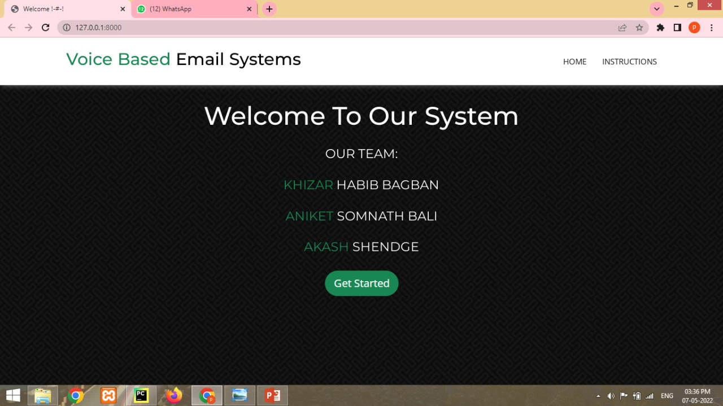

**Instruction Page**

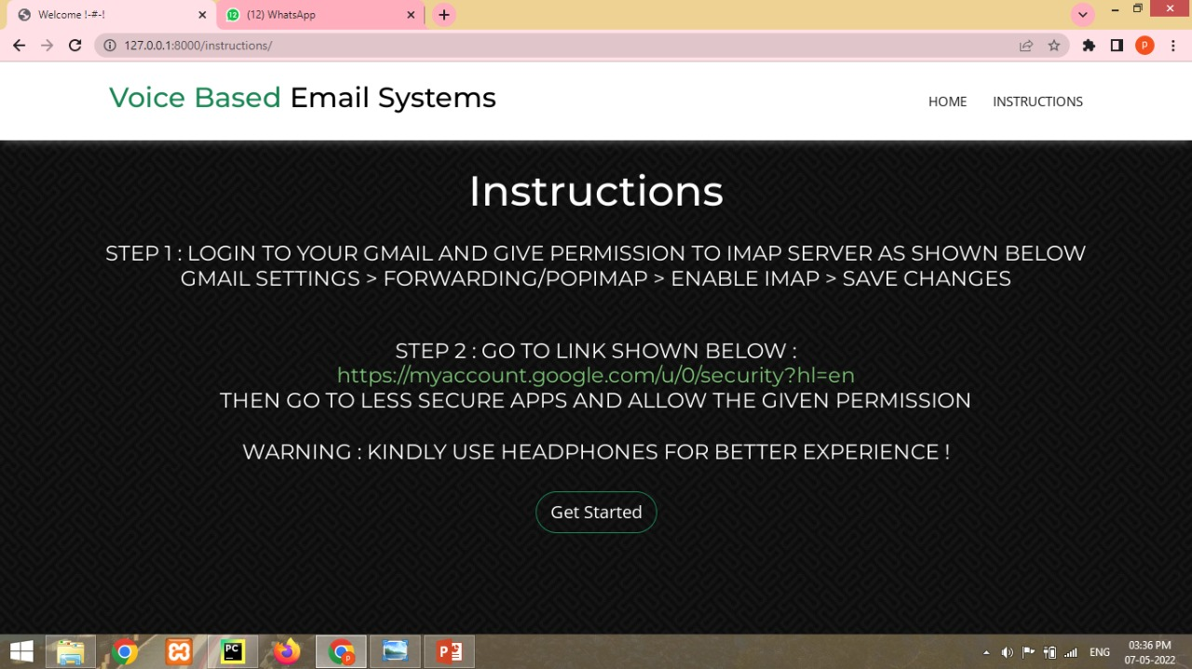

**Login Page**

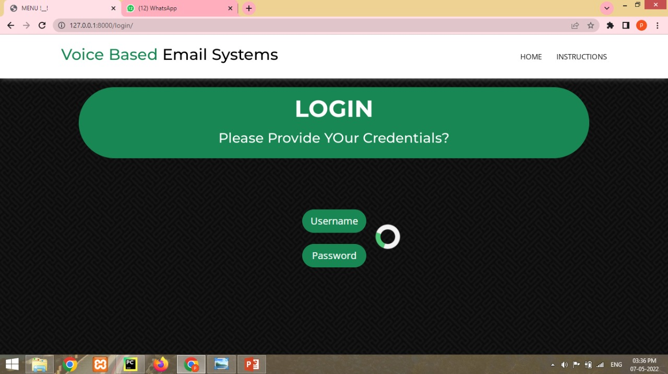

**Option Page**

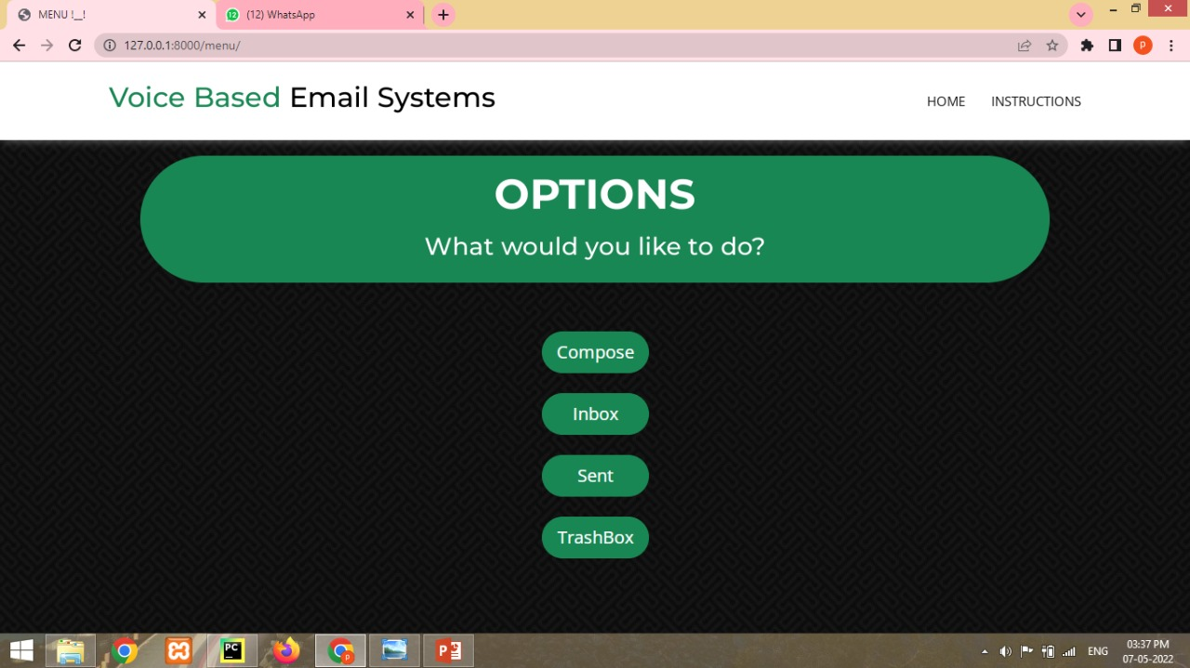

**Compose Page**

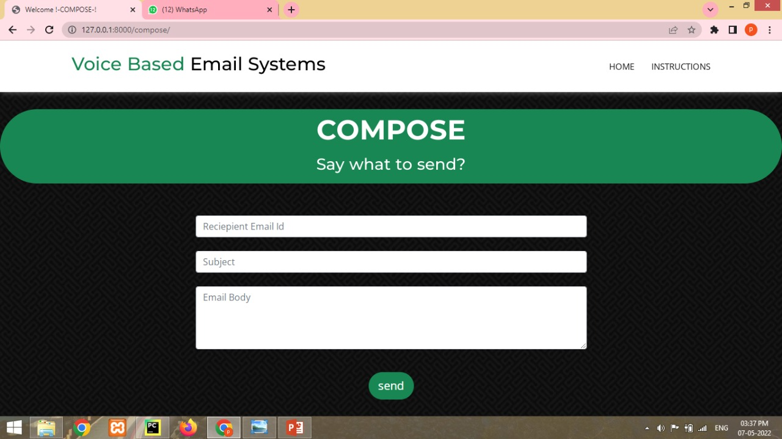

**Inbox Page**

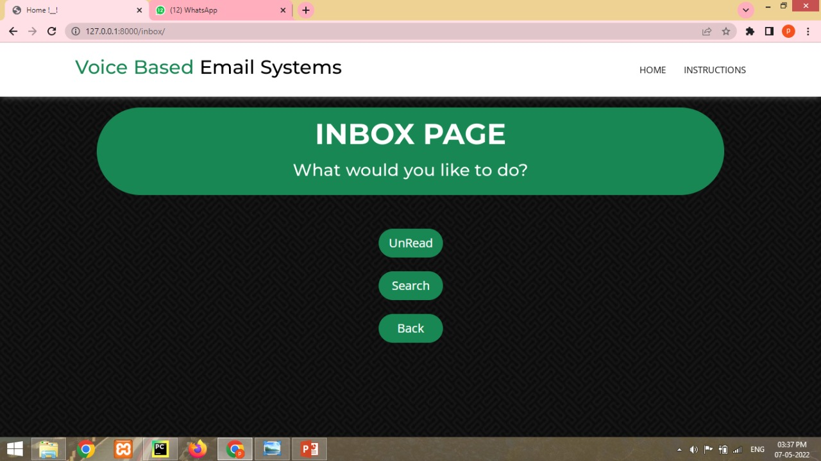

**Send mail Page**

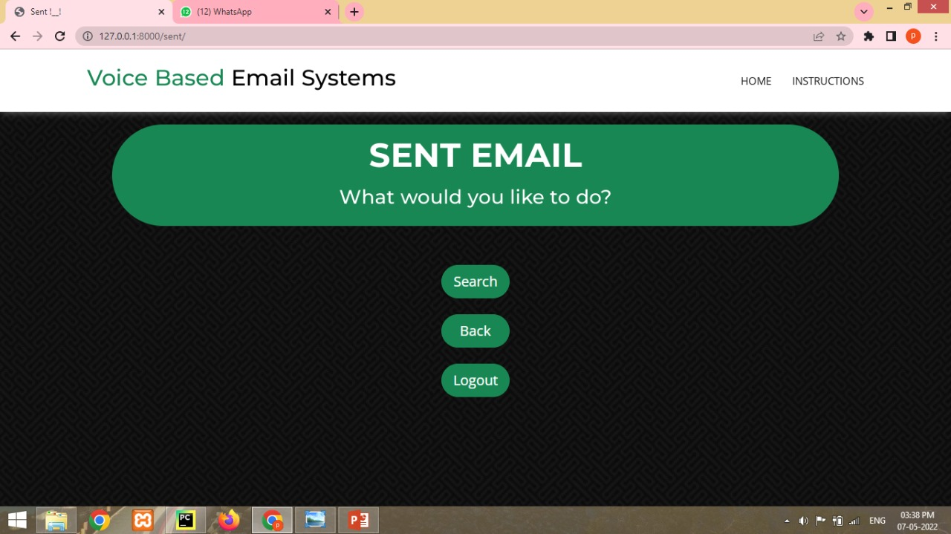

**Trashbox Page**

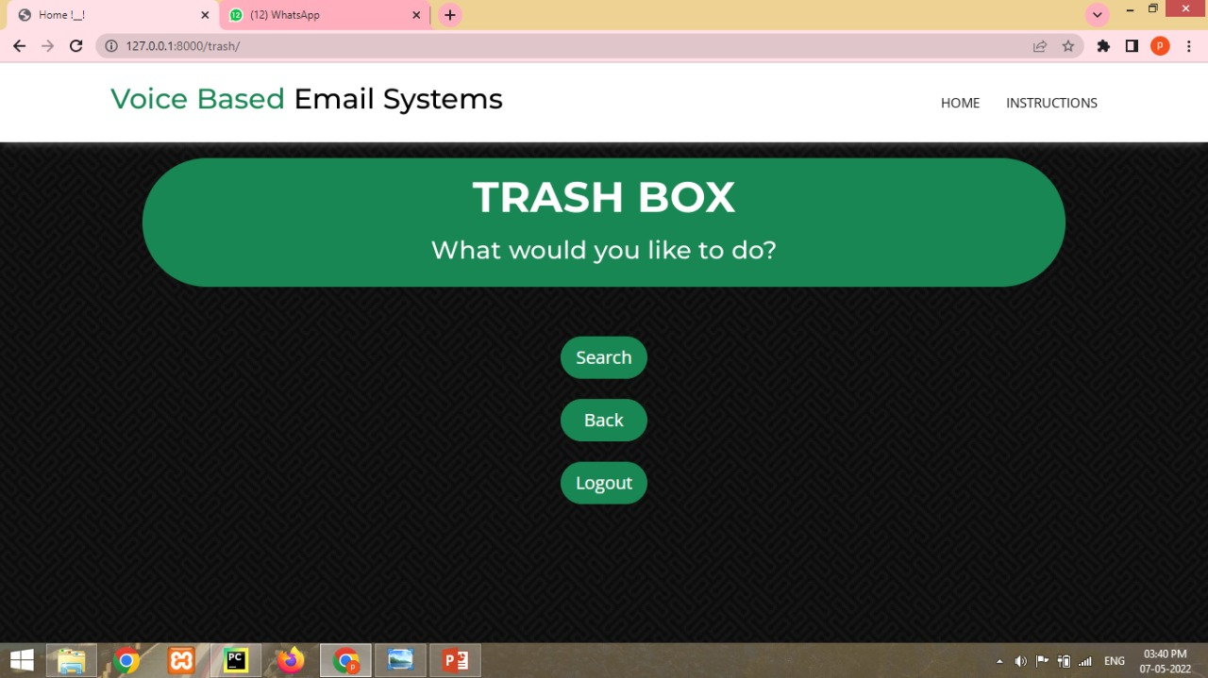

**CHAPTER 5:**

**5.1 Concusion**

The project that we have projected is a system which will help the visually impaired people to access email services efficiently.

This system will help in overcoming some drawbacks that were earlier faced by the blind people in accessing emails. We have eliminated the concept of using keyboard shortcuts along with screen readers which will help reducing the cognitive load of remembering keyboard shortcuts.

Also any non-sophisticated user who does not know the position of keys on the keyboard need not bother as keyboard usage is eliminated. Instructions given by the IVR accordingly to get the respective services offered.

Other than this the user might need to feed in information through voice inputs when specified. It is a observation that about 70% of total blind population across the world is present in INDIA. This project, describe the voice mail architecture used by blind people to access Email and multimedia functions of operating system easily and efficiently.

This architecture will also reduce cognitive load taken by blind to remember and type characters using keyboard. It also helps handicapped and illiterate people.

**5.2 Future Scope :-**

In future, Voice could be extended to image attachments and other options such as indentation, fonts etc., that are available with normal E-Mail.Can

make more reliable for blind to login to their account using facial recognition and making it more secure or using biometric to enhanced it security, use ml and al for increasing it speech recognition

**CHAPTER 6**

**REFERENCES**

1. Jagtap Nilesh, Pawan Alai, Chavhan Swapnil and Bendre M.R. , “Voice Based System in Desktop and Mobile Devices for Blind People ". International Journal of Emerging Technology and Advanced Engineering.

2. K. Jayachandran, P. Anbumani, “Voice Based Email for Blind People ", IJARIT, 2017.

3. Pranjal Ingle, Harshada Kanade, Arti Lanke, “Voice based voice mail System for Blinds ", IJRSCSE,2016.

4. Ummuhanysifa U.,Nizar Banu P K , “Voice Based Search Engine and Web page Reader. ", International Journal of Computational Engineering Research

5. The Radicati website. [Online]. Available: http://www.radicati.com/wp/wpcontent/uploads/2014/01/EmailStatistics-Report-2014-2018-Executive-Summary.pdf.

**Annexure A**

**Project Planner**



**Annexure B**

**Reviewers Comments of Paper Submitted**

(At-least one technical paper must be submitted in Term-I on the project design in the conferences/workshops in IITs, Central Universities or UoP Conferences or equivalent International Conferences Sponsored by IEEE/ACM)

1. Paper Title: **RANKING OF IMAGES BASED ON CAPTION ON SOCIAL MEDIA**
2. Name of the Conference/Journal where paper submitted : IRJET
3. Paper accepted/rejected : Accepted
4. Review comments by reviewer : Nothing
5. Corrective actions if any : Nothings

**Annexure C**

**Plagiarism Report**



# PLAGIARISM SCAN REPORT

|  |  |  |  |
| --- | --- | --- | --- |
| 2%  Plagiarised | 98%  Unique | **Date** | 2022-05-09 |
| **Words** | 940 |
| **Characters** | 5996 |

**Content Checked For Plagiarism**

ABSTRACT – web internet is one amongst the fundamental luxury for daily living. every body is exploitation the facts and knowledge on web. On the opposite hand, blind folks face problem in accessing the text resources. the event in pc based mostly handy systems has opened various opportunities for the visually disabled across. Audio response based mostly virtual surroundings, the screen readers square measure helps blind folks plenty to use web applications.

This project introduces the Voicemail system structural style that may be employed by a blind man to access E-Mails simply. The involvement of analysis helps blind individual to send and receive voice based mostly mails messages in their someone language with the assistance of a pc.

KEYWORDS: Speech Recognition,Speech toText, TexttoSpeech, Email, Internet, InteractiveVoiceResponse(IVR)

1. INTRODUCTION

We have seen that the beginning of web has dramatically revolutionized several fields. web has created lifetime of folks really easy that individuals nowadays have access to any data they need sitting at their home. one amongst the most fields that web has revolutionized is communication. And talking concerning communication over web, the primary issue that comes in our mind is E-mail. E-mails square measure thought of to be the foremost reliable manner of communication over web, for causing or receiving some vital data. however there's a special criteria for humans to access the net and also the criteria is you want to be ready to see. you want to be thinking that what variety of criteria is that this, all with eyes will see. however there are specially abled folks in our society United Nations agency aren't talented with what you have got. affirmative there square measure some visually impaired folks or blind people that can't see things and so can't see the pc screen or keyboard.

A survey shows that there square measure over 250 million visually impaired folks round the globe. That is, around 250 million folks square measure unaware of the way to use web or E-mail. the sole manner by that a visually impaired person will send associate E-mail is, they need to dictate the complete content of the mail to a 3rd person( not visually impaired ) then the person can compose the mail and ship the behalf of the visually impaired person.

But this is often not an accurate thanks to upset this downside. it's terribly less possible that each time a visually impaired person will notice someone for facilitate. though for these reasons the specially abled folks square measure criticized by our society.

So, for the better-ment of society associated giving an equal standing to such specially abled folks we've got come back up with this project plan that provides the user with ability to send mails exploitation voice commands while not the requirement of keyboard or the other visual things by solely exploitation speech and depression.

2. LITERATURE SURVEY

In paper [1], have projected associate email system that will be accessed simply by blind folks. The use of speech to Text device, Text to speech device and Viterbi algorithmic rule square measure taken into thought.. The algorithm works with the technique that the system detects the foremost acceptable word once the user spells it therefore matches the word that is guessed with the explicit word that is pronounced. The user desires to register to the web site after they visit the location for the primary time.

This system reduces some drawbacks of the present system

In paper [2] “Voice based mostly System in Mobile Devices for Blind People”. In International Journal of rising Technology and Advanced Engineering (IJETAE), 2014

This paper deals with “Voice based mostly System in Mobile Devices for Blind People”. Voice mail design helps blind folks

to access e-mail and alternative multimedia system functions of software package (songs, text). additionally in mobile application SMS will be browse by system itself.

In paper [3] “Voice based mostly program and web content Reader”. In International Journal of procedure Engineering analysis (IJCER)

This paper aims to develop a pursuit engine that supports Man-Machine interaction strictly within the style of voice. a unique Voice based mostly program and Web-page Reader that permits the users to command and management the net browser through their voice is introduced. the present Search Engines get request from the user within the style of text and respond by retrieving the relevant documents from the server and displays within the style of text to user

In paper [4] proposes a system for visually impaired and illiterate folks for rising their interaction with the email system. this method eliminates use of IVR Technology that used Screen Readers and Braille Keyboard.

There, have used Speech to text and Text to speech conversion. additionally for alternative operations voice commands. For registration, used email id and word. For the practicality, use a feature of PHP that's PHP mailer. it's a library which might be wont to send email.

3. PROSPOSED WORK

In the projected system, a net application is to be

Developed exploitation Python Django that may be used by folks with numerous visual impurities or unfit peoples, to access and manage emails simply and with efficiency. All the present voice based mostly email systems, give their own user developed email services and do not incorporate the use of Google’s Gmail. So, considering this here, the intention is to develop the application by linking it with the Gmail consumer, thereby giving users a further advantage of well unnatural format and simply accessed and managing Emails and numerous feature will be performed

And all the operation in projected model square measure done exploitation

Voice command and mouse clicks eg. causing mail, composing mail, forwarding mail etc

# Matched Source

**Similarity** 3%

**Title**:[www.researchgate.net](http://www.researchgate.net/) › profile › Sudhir-Bagade-2Voice based E-mail for the Visually Impaired

There, have used Speech to text and Text to speech conversion. Also for other operations voice commands. For registration, used email id and password. For the functionality, use a feature of PHP ...

[https://www.researchgate.net/profile/Sudhir-Bagade-2/publication/344296191_Voice_based_E-](http://www.researchgate.net/profile/Sudhir-Bagade-2/publication/344296191_Voice_based_E-) mail_for_the_Visually_Impaired/links/5f646319a6fdcc0086297a53/Voice-based-E-mail-for-the-Visually-Impaired.pdf? origin=publication_detail/



**ANNEXURE D**

**INFORMATION OF PROJECT GROUP MEMBERS**



**Name :-** Khizar Bagban

**Date of Birth :-** 06-08-2000

**Gender :-** Male

**Permanent Address :-** Ahmednagar

**Email :-** khizarbagwan786@gmail.com

**Mobile No :-**9075594483

**Placement Detals :-** None

**Paper Published :-** 1



Name :- Aniket Bali

Date of Birth :- 21-01-2001

Gender :- Male

Permanent Address :- Ahmednagar

Email :- aniketbali777@gmail.com

Mobile No :-7774928309

Placement Detals :- None

Paper Published :- 1



Name :- Akash Shendge

Date of Birth :- 14-06-1999

Gender :- Male

Permanent Address :- At.Post. Purushottampuri Tq.Majalgaon Dist.Beed

Email :- akashshendge21@gmail.com

Mobile No :- 9011330505

Placement Detals :- None

Paper Published :- 1